**Department of Computer Science and Engineering**

|  |  |
| --- | --- |
| **Course Code:CSE260** | **Credits: 1.5** |
| **Course Name: Digital Logic Design** | **Semester: Fall’18** |

**Lab 01  
Introduction to Fundamental Logic Gates**

1. **Topic Overview:**

The students will familiarize themselves with the logic gates in this lab. They also learn how the IC of different logic gates work.

1. **Lesson Fit:**

There is no pre-requisite to this lab

1. **Learning Outcome:**

After this lecture, the students will be able to:

* 1. Use logic gates
  2. Use IC
  3. How to set up IC on bread board

1. **Anticipated Challenges and Possible Solutions**

**Problem:** Student may not understand how to set up ICs on bread board.

**Solution:** Demonstrate them the process for an IC

1. **Acceptance and Evaluation**

Students will show their progress as they complete each problem. They will be marked according to their class performance. Their maybe students who might not be able to finish all tasks, they will submit them later and give a viva to get their performance mark.

1. **Activity Detail**
   1. **Hour: 1  
      Discussion:**Explain the logic gates, ICs, Bread Boards and Power board. **Problem Task:** Set up and OR ICs
   2. **Hour: 2 & 3**

**Discussion:**

Other logic gates

**Problem Task:** Set up these ICs

1. **Home tasks**
   1. Find out truth table of other basic function

**Lab 1 Activity List**

# Experiment # 1

## Familiarization of Fundamental Logic Gates

**Objective:**

* To get familiarized with fundamental logic gates and demonstrate the input output relationship of 2-input **AND (IC – 7408), OR (IC – 7432) and NOT (IC – 7404)** gates by constructing their truth tables.
* To get familiarized with other logic gates like **NAND (IC – 7400), NOR (IC – 7402)**, **XOR (IC – 7486)** and **XNOR (IC – 74266)**

**Procedure:**

For each of the ICs’, place IC correctly on the trainer board

* Remember each IC’s pin 14 connected to “+5V” position of DC Power Supply of the trainer board, and pin 7 connected to “GND” position.
* Connect the inputs to Data switches and the output to any position of the LED Display.
* Find out the outputs for all possible combinations of input states.
* Write down the input-output in tabular form.

***Report:***

The report should cover the followings

Name of the Experiment

1. Objective
2. Required Components and Equipments
3. Experimental Setup
4. Results (Truth Table) and Discussions

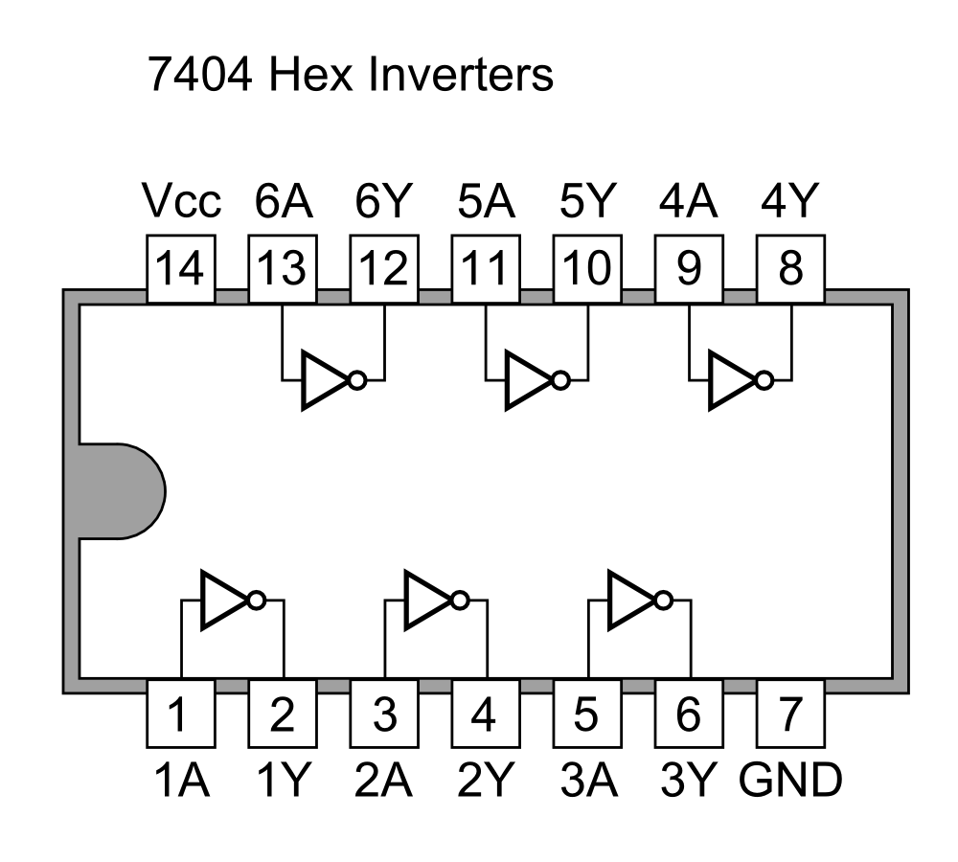

Pin layout of 7404

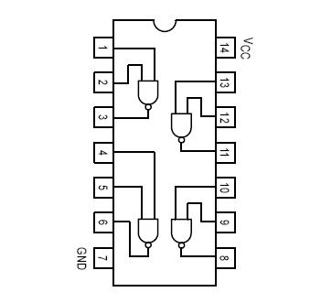

Pin layout of 7400

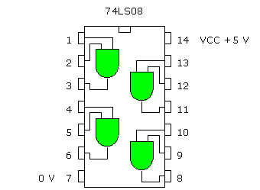

Pin layout of 7408

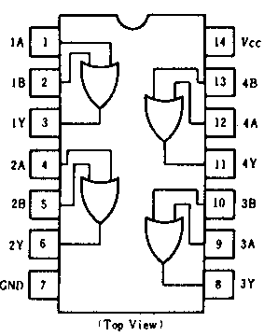

Pin layout of 7432

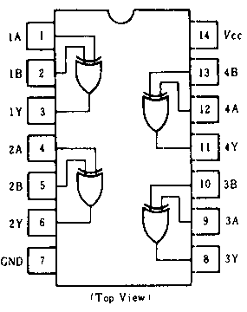

Pin layout of 7486

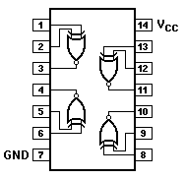

Pin layout of 74266

Pin layout of 7402

